**Mystifier**

**Architecture Solution**

**Question #1:*Do you agree with Mystifier to store external system data of users on their servers? Please answer with reasoning.***

***Answer:*** *It all depends on the business needs. I would agree with the CTO’s decision to store the data to the external system based onthe following points:*

1. *Data can be processed to extract information that can be useful forMystifier.*
2. *They can use that data to help other businesses.*
3. *They can provide their users with different filtration options for reports.*
4. *Every social networking API comes up with a rate limit. It can be consumed to its limit if we query API every time the user asks for report.*
5. *It could delay the response if we had to generate the report through API every time.*

***Question2#: What would be application architecture?***

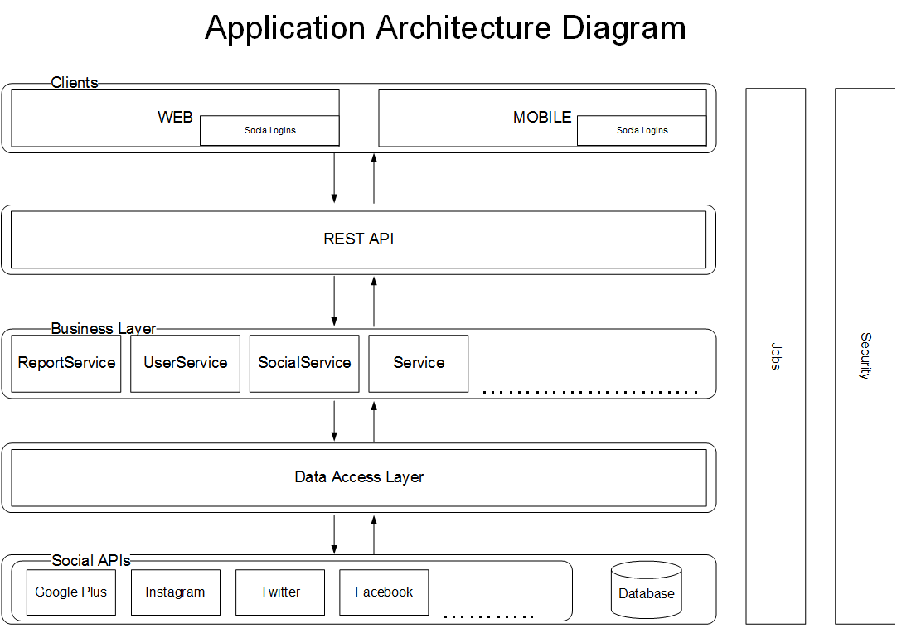

***Question3#: Please create ERD with current information in hand.***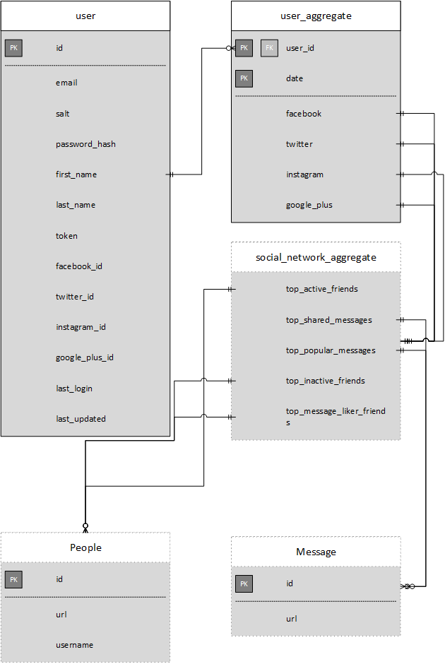

***Question4#: Please draw deployment diagram of above proposed solution.***

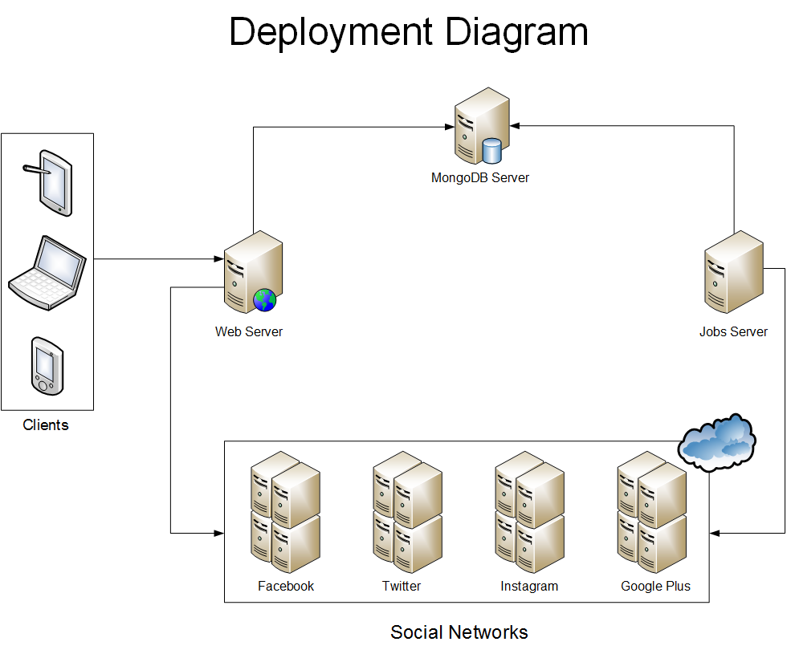

***Question5#: Which technologies you will propose to build above solution (Programming language, database etc)?***

***Answer:***

**Backend:** Nodejs

**Frontend:** Angularjs

**Database:** MongoDB

***Question6#: Mystifier has done marketing push now they are expecting X number of users do you think proposed architecture will support X number of users and can be scaled up with company growing needs, if not then what changes are required to make solution scalable?***

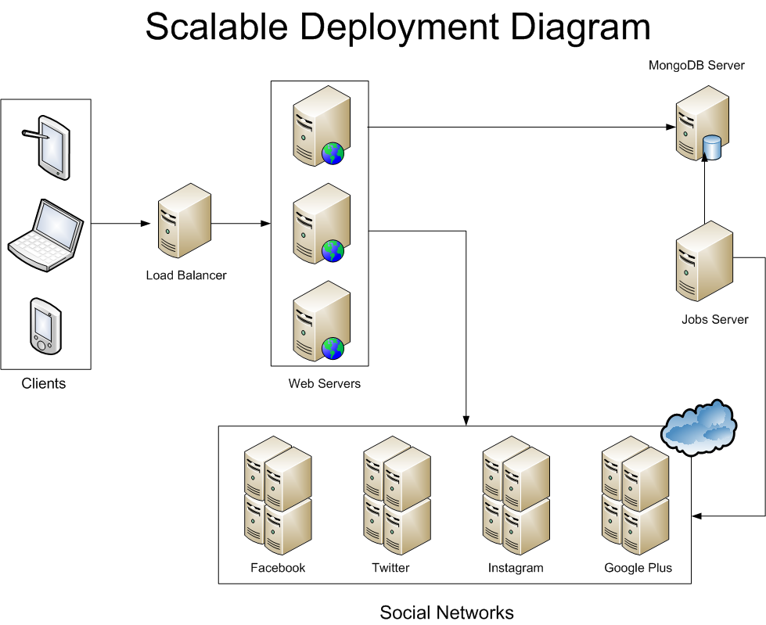To make the solution scalable we can make some changes:

1. Add a load balancer before the web servers. After that all requests will be directed to the load balancer and load balancer is responsible to redirect it to the appropriate server.
2. For database, we can vertically scale to improve performance, if possible. We can also horizontally scale the database with the technique called sharding.